

Assignment – 3

• Use the Employee Details dataset and perform the following activities: -

− Split the column CITY and separate the code associate with each city like - Allahabad[AL2] should be only Allahabad and [A2] will be separate.

− Extract the first name from EMPLOYEE NAME column and transform the column.

− Using the JOINING DATE column extract the Year and no. of days for that month .

− Create a visual of your choice and show the how much salary has been paid to each state and which state has lowest payout.

Point 1:-
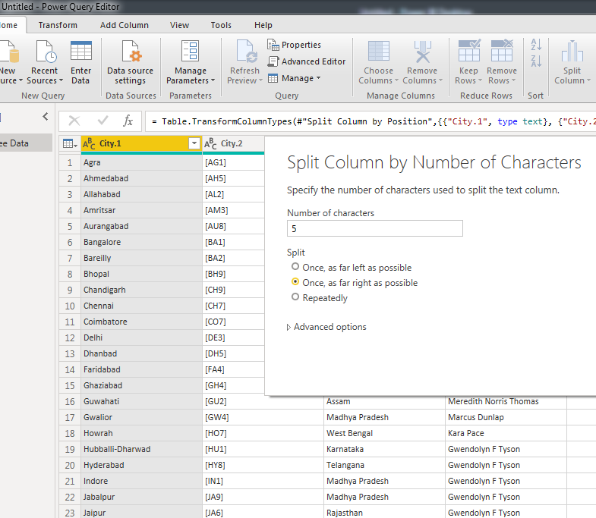

Point 2:-
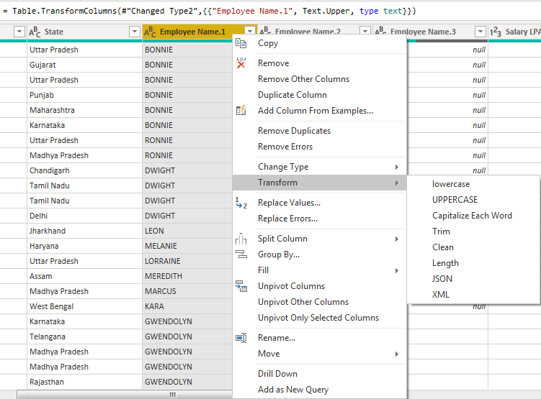

Point 3 :-

extract the Year
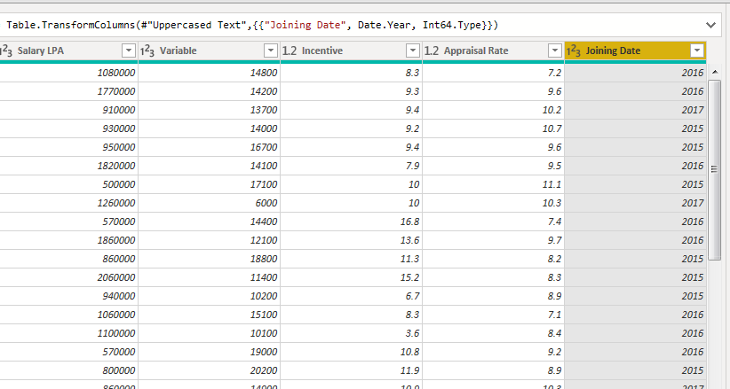

no. of days for that month
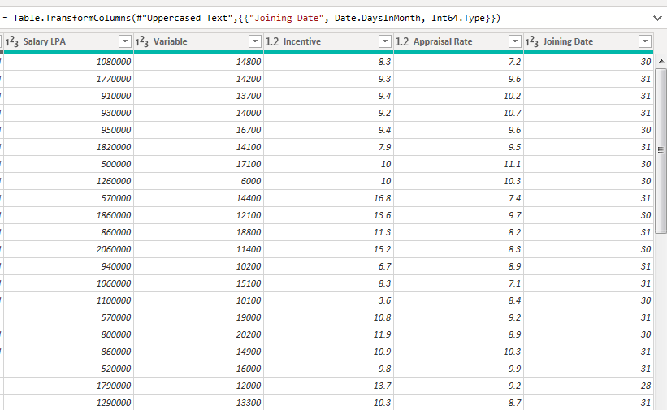

Answer -4
